# Using AWS CloudFront

## What is CloudFront

Amazon CloudFront is AWS's content delivery network (CDN) service designed to improve website and application performance by distributing content to users with low latency.

Key Features and Benefits

* **Global Content Delivery**: CloudFront uses a worldwide network of edge locations to cache and deliver content closer to users, reducing latency.
* **Security**: Integrates with AWS Shield for DDoS protection, and AWS WAF (Web Application Firewall) to filter malicious traffic.
* **Integration with AWS Services**: Works seamlessly with other AWS services like S3, EC2, Elastic Load Balancing, and Lambda@Edge.
* **Customizable Caching**: Allows you to control how long content stays cached at edge locations.
* **HTTPS Support**: Provides TLS/SSL encryption and HTTPS support at no additional cost.

## Goals for using CloudFront for our website

Get HTTPS connection between client and AWS

Speed up load times with caching for clients.

# Check load times of our website

### Connect to Asia

If you have a VPN connection, connect to any servers in Asia. If you don’t, either find a partner near you that does or connect to the link provided (this website is hosted in asia)

_____ insert link here



### Open the developer console on your browser.

Make sure you disable the cache on your browser and press reload.

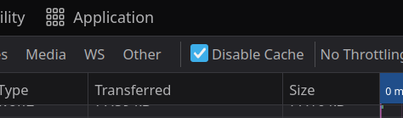

### Now sort by loading time.

See how long it takes to load the longest resources (How many seconds is 2000 ms?)

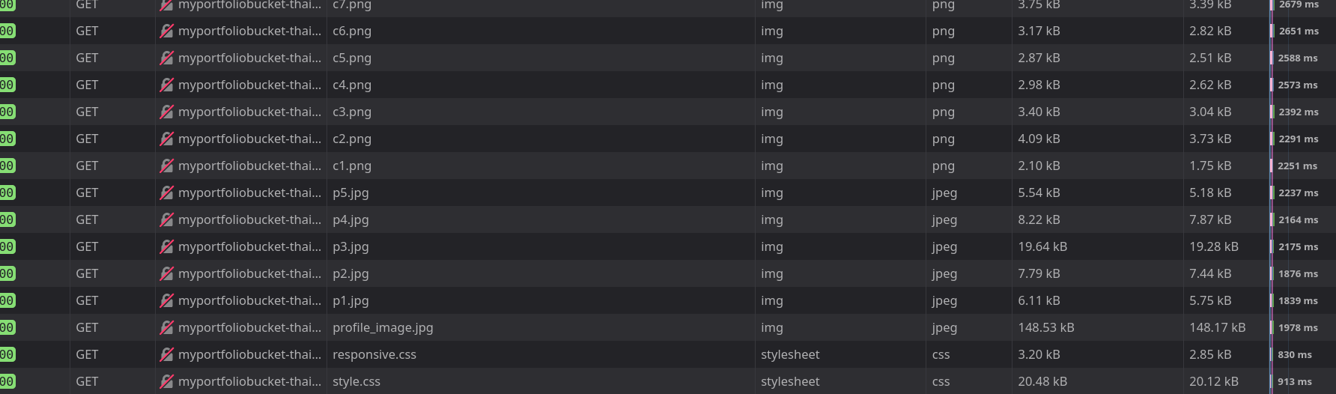

## Set up Cloud Front distribution

### Go to cloud front dashboard and create a distribution

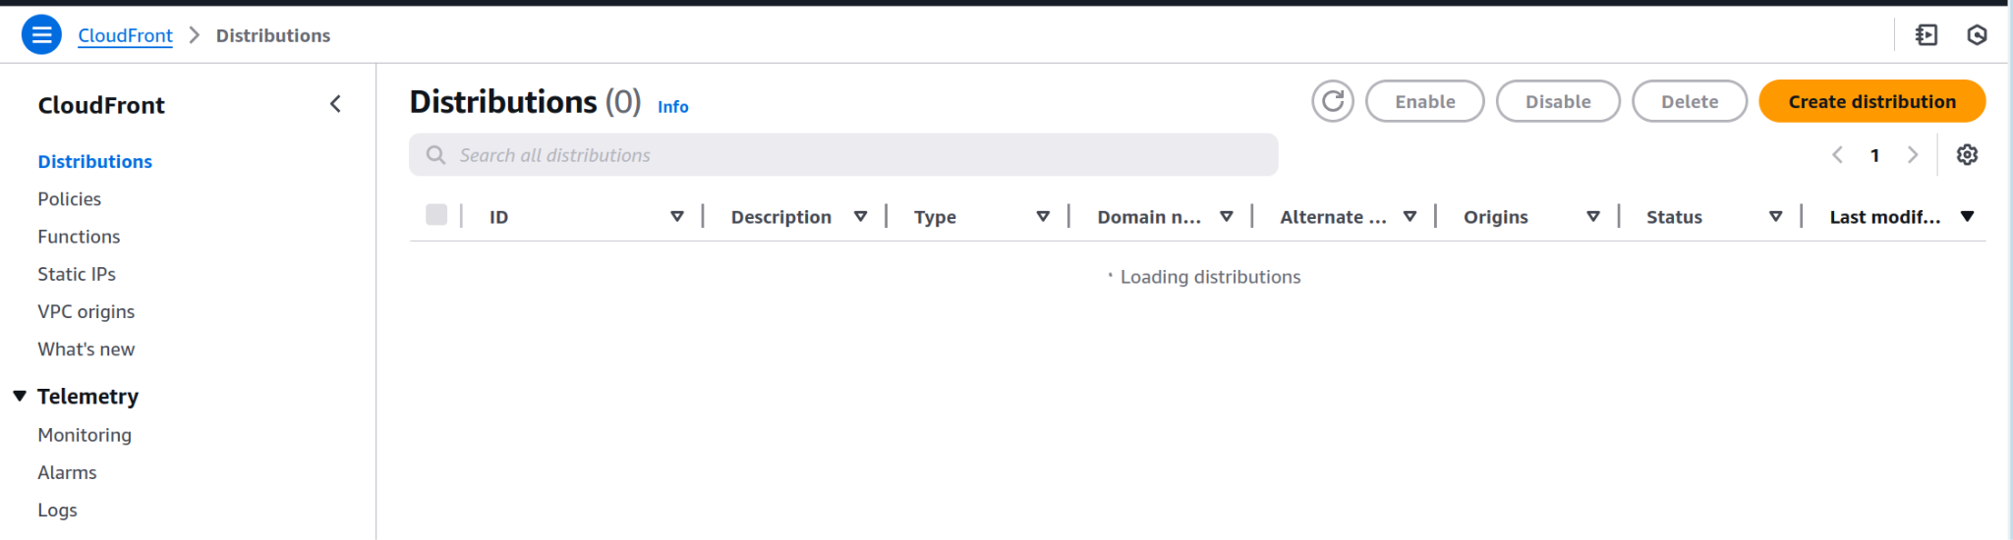

### Use your bucket as origin

Find your bucket domain and set your website bucket as the origin.

Use the website endpoint when this message pops up

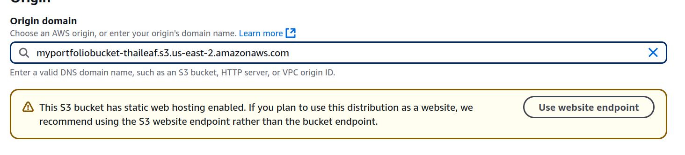

### Disable WAF

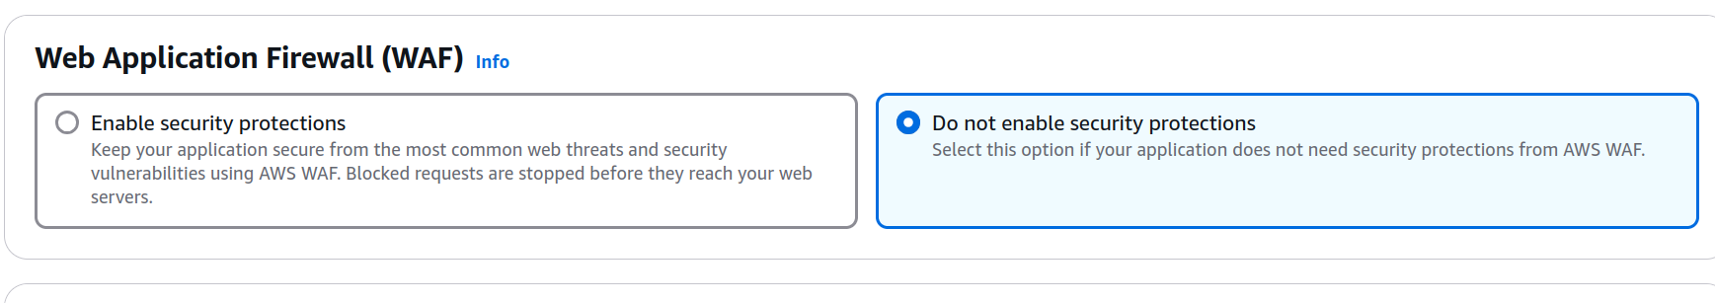

### Observe the other settings

Check out the other settings, but keep everything at default. Then create it.

## Use the new distribution

Wait for it to finish deployment, then use the distribution domain name and paste it into your browser.

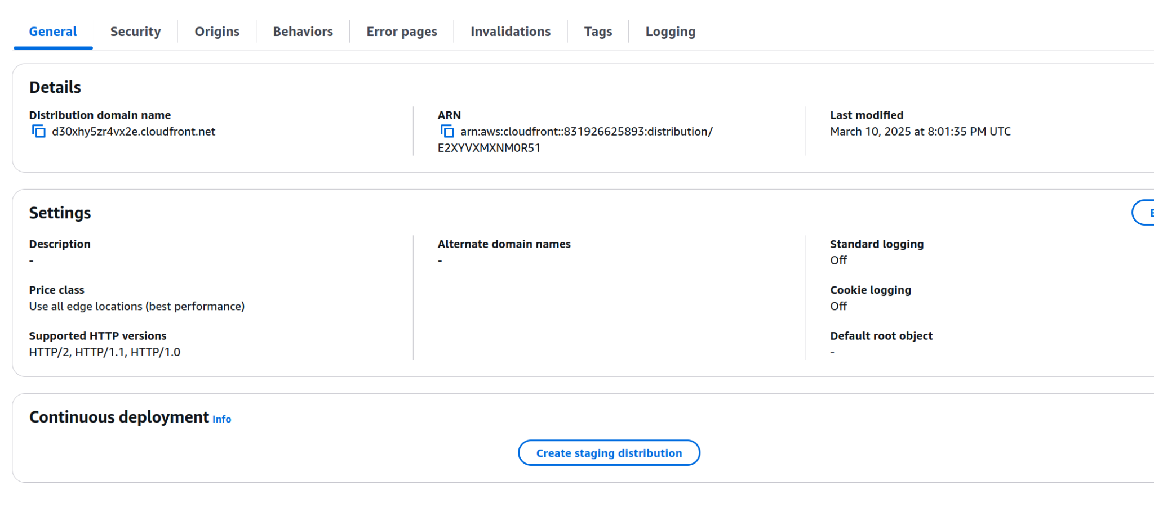

Notice that we have https now



## Check load times of CDN

### Time your response again. The first load should take about the same time as last time, maybe less.

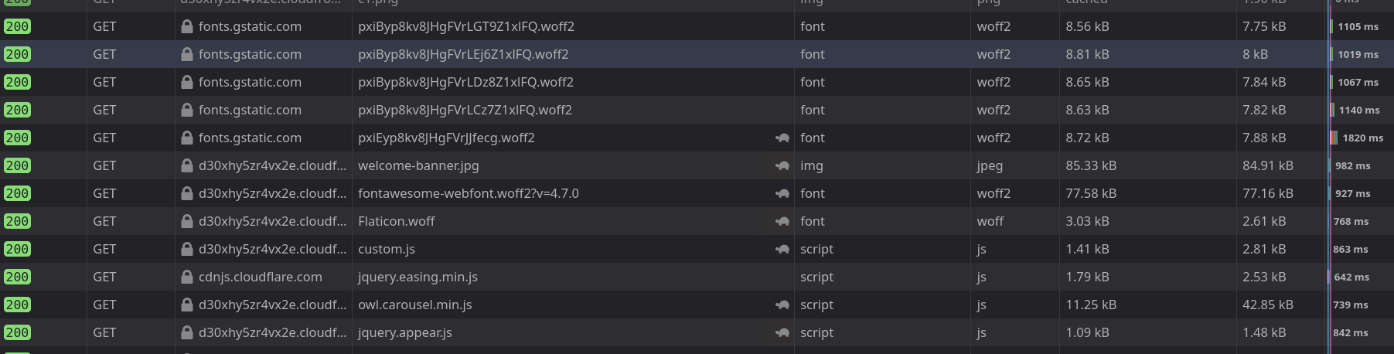

### The second load should take much less time now that it has cached it at the CDN level

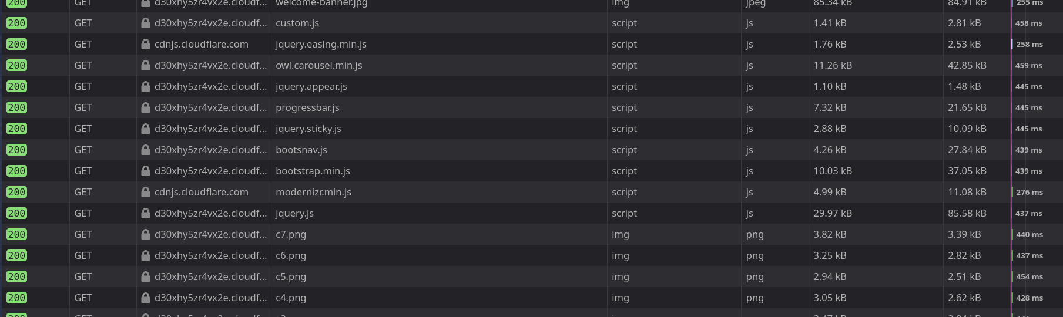

Congratulations.